Answers

**Module 2**

**In this unit, you are going to learn:**

1. Adjective Patterns
2. Connectives
3. Contrasting ideas
4. Showing results
5. Adding information
6. Happening at the same time



**Part A Adjective Patterns**

**We use adjective patterns to say what we think.**

**Pattern 1: It is / It’s (not) + adjective + to-infinitive (i.e. to + verb in base form)**

|  |  |  |
| --- | --- | --- |
| ***It is / it’s (not)*** | ***adjective*** | ***to-infinitive*** (to + verb in base form) |
| **1. It is** | **fun** | **to learn English grammar.** |
| **2. It isn’t** | **boring** | **to read English books.** |
| **\*\*3. Is it** | **easy** | **to study English well?** |

**Exercise 1a**

**Write sentences/questions using the words given in the correct order.**

**Use Adjective Pattern 1 ‘*It is / It’s (not) + adjective + to-infinitive’.***

e.g. to / **interesting** / It / watch / is / Disney cartoon

🡪 It is interesting to watch Disney cartoon.



1. sleep / in class / is / **wrong** / It / to

It is wrong to sleep in class.

1. **easy** / write / is / It / to / in English / not

It is not easy to write in English.



1. it / **expensive** / to / Is / study / in the UK

Is it expensive to study in the UK?

**Exercise 1b**

**Write sentences/questions using Adjective Pattern 1.**

e.g. Going hiking alone is **dangerous**.

🡪 It is dangerous to go hiking alone.



1. Listening to music is **relaxing**.

It is relaxing to listen to music.

1. Playing in the library is not **right**.

It is not right to play in the library.



1. Is doing money origami **difficult**?

Is it difficult to do money origami?

**Pattern 2: It is / It’s (not) + adjective + FOR somebody + to-infinitive**

|  |  |  |  |
| --- | --- | --- | --- |
| ***It is/ It’s (not)*** | ***adjective*** | ***for somebody***  ***(i.e. pronoun/noun/noun phrase)*** | ***to-infinitive*** |
| **1. It’s** | **hard** | **for me** | **to cook dinner alone.** |
| **2. It isn’t** | **possible** | **for Ben** | **to sit quietly.** |
| **\*\*3. Is it** | **important** | **for Hong Kong students** | **to learn English?** |

**Exercise 2a**

**Write sentences/questions using the words given in the correct order.**

**Use Adjective Pattern 2 ‘*It is / It’s (not) + adjective + for somebody + to-infinitive’.***

e.g. to / **impossible** / It / wake up early / is / Jack / for /

🡪 It is impossible for Jack to wake up early.



1. do / for / is / **good** / It / to / young people / more exercise

It is good for young people to do more exercise.



1. **necessary** / fill in / Is / to / for / this form / it / us

Is it necessary for us to fill in this form?

1. is / **healthy** / to / It / eat / not / Ben / too much / for

It is not healthy for Ben to eat too much.

**Exercise 2b**

**Write sentences/questions using Adjective Pattern 2.**

Mike wants to go hiking alone, but it is **dangerous**.

🡪 It is dangerous for Mike to go hiking alone.



1. Dan wants to make a cake. He thinks it is easy.

It is easy for Dan to make a cake.

1. Jenny brings $1000 to school every day. It is not **safe**.

It is not safe for Jenny to bring $1000 to school every day

1. Chris wants to eat a hamburger in 30 seconds. Is it **possible**?



Is it possible for Chris to eat a hamburger in 30 seconds?

**Pattern 3: Subject + be (not) + adjective + to-infinitive**

|  |  |  |  |
| --- | --- | --- | --- |
| ***Subject*** | ***be (not)*** | ***adjective*** | ***to-infinitive*** |
| **1. He** | **is** | **sad** | **to hear the bad news.** |
| **2. My parents** | **are** | **happy** | **to see my improvement.** |
| **3. Japanese** | **is not** | **easy** | **to learn.** |
| **\*\*4. Is** | **the talk show** | **fun** | **to watch?** |

**Exercise 3a**



**Write sentences/questions using the words given in the correct order.**

**Use Adjective Pattern 3 ‘*Subject + be (not) + adjective + to-infinitive’.***

e.g. Mum / the broken vase / see / **angry** / is / to

🡪 Mum is angry to see the broken vase.

1. are / their idol / talk with / **excited** / The kids / to

*The kids* are excited to talk with their idol.

1. **hard** / answer / is / This question/ to / not /



This question is not hard to answer.

1. Are / **ready** / to / the discussion / the students / start

Are *the students* ready to start the discussion?

**Exercise 3b**

**Write sentences/questions using Adjective Pattern 3.**

Dad is fixing the computer. It is **difficult**.



🡪 The computer is difficult to fix.

1. Vincent wants to make a model Gundam. It looks quite **simple**.

The model Gundam is simple to make

1. Amy wants to buy these jeans. They are not **cheap**.

The jeans are not cheap to buy.



1. Miss Chan wants me to carry these books to the staffroom --- Are they **heavy**?

Are the books heavy to carry?

**Pattern 4: Subject + be (not) + adjective + ENOUGH + to-infinitive**

|  |  |  |  |  |
| --- | --- | --- | --- | --- |
| ***Subject*** | ***be (not)*** | ***adjective*** | ***enough*** | ***to-infinitive*** |
| **1. Bobby** | **is** | **smart** | **enough** | **to answer the question.** |
| **2. I** | **am not** | **tall** | **enough** | **to change the light bulb.** |
| **3. We** | **are** | **old** | **enough** | **to travel alone.** |
| **\*\*4. Is** | **your eyesight** | **good** | **enough** | **to read the map?** |

**Exercise 4a**

**Write sentences/questions using the words given in the correct order.**

**Use Adjective Pattern 4 ‘*Subject + be (not) + adjective + enough + to-infinitive’.***

e.g. Jane / the skirt / fit in / enough / **thin** / is / to



🡪 Jane is thin enough to fit in the skirt.

1. Is / the volleyball team / enough / join / **skilful** / he / to

Is he skilful enough to join the volleyball team?

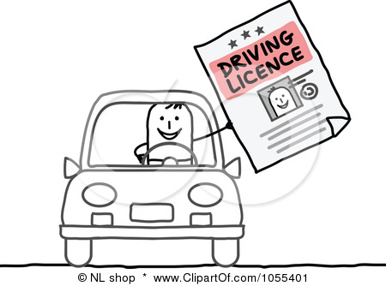

1. **old** / am / get a driving licence / I / to / enough

I am old enough to get a driving licence.

1. is / enough / **fit** / to / not / Annie / run 10 km

Annie is not fit enough to run 10 km.

**Exercise 4b**

**Write sentences/questions using Adjective Pattern 4.**

We can all understand the story. It is **simple**.

🡪 The story is simple enough to understand.



1. I can fall asleep in 10 seconds. I am very **tired**.

I am tired enough to fall asleep in 10 seconds.

1. The shoes don’t fit Tim. They are too small. (not **big**)

The shoes are not big enough to fit Tim.

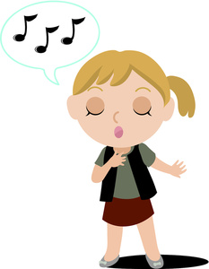

1. Can Joey win the singing contest? She is not **good** at singing.

Is Joey good enough to win the singing contest?

**Pattern 5: It is / It’s (not) + adjective + that-clause (i.e. that + subject + verb…)**

|  |  |  |
| --- | --- | --- |
| ***It is/ It’s (not)*** | ***adjective*** | ***that-clause*** (that + subject + verb) |
| **1. It is** | **clear** | **that cheating is wrong.** |
| **2. It’s not** | **normal** | **that Sally doesn’t talk to us.** |
| **\*\*3. Is it** | **Important** | **that we eat a balanced diet?** |

**Exercise 5a**

**Write sentences/questions using the words given in the correct order.**

**Use Adjective Pattern 5 ‘*It is / It’s (not) + adjective + that-clause’.***

e.g. that / our class / It / won / **good** / is / the singing contest

🡪 It is good that our class won the singing contest.

1. is / that / late for school / **common** / is / It / not / Jason /

It is not common that Jason is late for school.

1. **certain** / it / that / Simon / the meeting / Is / will attend

Is it certain that Simon will attend the meeting?



1. is / ate / **crazy** / 10 pizzas for lunch / It / Paul / that

It is crazy that Paul ate 10 pizzas for lunch.

**Exercise 5b**

**Write sentences/questions using Adjective Pattern 5.**

Bob did well in the exam. --- It is **surprising**.

🡪 It is surprising that Bob did well in the exam.



1. No one got full marks in the quiz. --- It is **disappointing**.

It is disappointing that no one got full marks in the quiz.

1. Nick has to do all the housework. --- It is not **fair**.

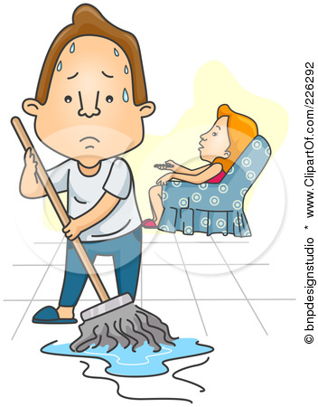

It is not fair that Nick has to do all the housework.

1. Many people don’t take good care of their pets. --- Is it **terrible**?

Is it terrible that many people don’t take good care of their pets?

**Pattern 6: It is / It’s (not) + adjective + OF somebody + to-infinitive**

|  |  |  |  |
| --- | --- | --- | --- |
| ***It is/ It’s (not)*** | ***\*adjective*** | ***of somebody***  ***(i.e. pronoun/noun/noun phrase)*** | ***to-infinitive*** |
| **1. It is** | **nice** | **of you** | **to help me.** |
| **2. It’s not** | **polite** | **of Michael** | **to speak so loudly.** |
| **\*\*3. Is it** | **kind** | **of the bus driver** | **to wait for us?** |

***\* The adjective is used to talk about the quality of people.***

**Exercise 6a**

**Write sentences/questions using the words given in the correct order.**

**Use Adjective Pattern 6 ‘*It is / It’s (not) + adjective + of somebody + to-infinitive’.***

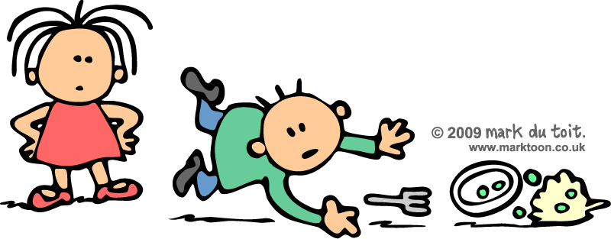

e.g. of / to / It / his lunch / **careless** / is / Joe / drop

🡪 It is careless of Joe to drop his lunch.

1. to / of / share / **generous** / is / It / Jason / his snacks / with us



It is generous of Jason to share his snacks with us.

1. **sensible** / it / walk in the rain / Katie / Is / of / to

Is it sensible of Katie to walk in the rain?

1. is / run near the swimming pool / **wise** / to / It / the kids / not / of

It is not wise of the kids to run near the swimming pool.

**Exercise 6b**

**Write sentences/questions using Adjective Pattern 6.**

Mike always gets high marks in the tests. He is **clever**.

🡪 It is clever of Mike to get high marks in the tests.

1. The boys throw rubbish on the floor. They are not **responsible**.

It is not responsible of the boys to throw rubbish on the floor.

1. Tina always gives help to her class teacher. She is very **helpful**.

It is very helpful of Tina to always give help to her class teacher.



1. Thomas tells lies all the time. Is he **right**?

Is it right of Thomas to tell lies all the time?

**Exercise 7**

**Put the words in the correct order to make meaningful sentences.**

1. not / old people / **easy** / It / a new language / is / learn / to / for /.

It is not easy for old people to learn a new language.

1. to / My parents / my poor exam results / **shocked** / were / see

My parents were shocked to see my poor exam results.

1. make changes / for / Is / too **late** / to / it / him

Is it too late for him to make changes?

1. to / swimming / It / **dangerous** / is / go / alone

It is dangerous to go swimming alone.

1. to / of / not / sleep in class / It’s / Benny / **polite**

It is not polite of Benny to sleep in class.



1. Are / to ride / the kids / **tall** / the roller coaster / enough

Are the kids tall enough to ride the roller coaster?

1. is / Paul / that / **normal** / It / doesn’t talk with us / this week / not

It is not normal that Paul doesn’t talk with us this week.

**Exercise 8**

**Make sentences/questions using Adjective Patterns.**

1. Having too much fast food is **unhealthy**. Pattern 1

It is unhealthy to have too much fast food.

1. 3E students want to learn Adjective Patterns well. It is not **hard**. Pattern 2

It is not hard for 3E students to learn Adjective Patterns well.

1. I want to make this cake. Is it **easy**? Pattern 3

Is this cake easy to make?

1. Joe can lift 3 chairs at one time. He is very **strong**. Pattern 4

Joe is strong enough to lift 3 chairs at one time.

1. All 3E students can pass the mid-term test. It is **possible**. Pattern 5

It is possible that all 3E students can pass the mid-term test.



1. The tourists are walking on the grass. It is not **right**. Pattern 6

It is not right of the tourists to walk on the grass.

**Exercise 9**

Complete the following sentences using the adjective patterns and the adjectives in the word box. Use each adjective once only.

|  |  |  |  |
| --- | --- | --- | --- |
| allowed | convenient | fair | foolish |
| interesting | kind | surprising | useful |

1. _It’s useful_ to speak foreign languages.
2. __It was kind of__ Lisa to lend me her smartphone.
3. __Is it fair that_ I had to wash the dishes alone?
4. __It was interesting for__ us to see the performance.
5. _It’s not / It isn’t surprising that__ the stronger team won the match.
6. _It’s not / It isn’t allowed to_ walk dogs in the park.
7. _It’s foolish of__ Karen to carry so many plates in one go.
8. _It’s convenient for_ me to take the bus to school.

**Part B. Connectives**

**A.1 Contrasting ideas**

**( but / However, / Nevertheless, / Nonetheless, / although / Although… , / Even though / though )**

**A.1.1 Notes**

|  |
| --- |
| **We want to play tennis but we cannot play it.**  **This is because it is raining now.** |

* We use **‘but’** to **link two contrasting ideas**.
* ‘but’ is often used **in the middle** of a sentence. We do not repeat all the words when ideas are joined by ‘but’.
* Usage 1: Idea 1: **We want to play tennis. ☺**

Idea 2: **We cannot play tennis. ☹**

**🡺 We want to play tennis but we cannot play it. (tennis)**

* Usage 2: Idea 1: **A rich man is always happy. Mr. Li is rich. ☺**

Idea 2: **He is unhappy. ☹ (Focused meaning)**

🡺 **Mr. Li is rich but unhappy. (He is)**

**A.1.1 Exercise – Linking up 2 contrasting ideas**

Join the following sentences using the connectives **‘but’**. For questions 2 - 4, tick () the box next to the correct sentence.



|  |  |
| --- | --- |
|  | 1. It rained briefly. It rained heavily.  Example: It rained **briefly but heavily**. |
|  | 2. The trip was tiring. The trip was enjoyable.  a. The trip was tiring. But it was enjoyable. □  b. The trip was tiring but enjoyable. **〼** |
|  | 3. The holiday was very good. The hotel was not nice.  a. The holiday was very good but not nice. □  b. The holiday was very good but the hotel was not nice. **〼** |
|  | 4. It rained all day. The bad weather did not make us unhappy.  a. It rained all day, But the bad weather did not make us unhappy. □  b. It rained all day but it did not make us unhappy. **〼** |

**A.1.2 Notes**

|  |
| --- |
| **The reporter asked the rich man a good question. However, he did not answer it.** |

* We use **‘However, / Nevertheless, / Nonetheless,’** to **link two contrasting ideas** and **to introduce a surprising or unexpected idea**.
* Tone: **Formal**.
* **‘However, / Nevertheless, / Nonetheless,’** are often used **at the beginning** of a sentence, followed by a **comma**.
* Usage: Idea 1: **I think you are not clever. ☹**

Idea 2: **You will pass your exams. ☺**

This is because you have work very hard.

**🡺 I think you are not clever. However, you will pass your exams.**

**A.1.2 Exercise – Linking up 2 contrasting ideas**

Join the following sentences using the following connectives. For questions 2, tick () the box next to the correct sentence.



**However, / Nevertheless, / Nonetheless,**

|  |  |
| --- | --- |
|  | 1. The Hong Kong Observatory is putting up the black rainstorm signal. It will not be for a long time.  Example: The Hong Kong Observatory is **putting up** the black rainstorm signal. **However,** **it will not be for a long time**. |
|  | 2. I felt tired for picking up the rubbish at the beach. It was meaningful.  a. I felt tired for picking up the rubbish at the beach, nevertheless it was meaningful. □  b. I felt tired for picking up the rubbish at the beach. Nevertheless, it was meaningful. **〼** |
|  | 3. The woman was happy about the beautiful beach. She was angry about the dirty hotel.  The woman was happy about the beautiful beach. However / Nevertheless / Nonetheless, she was angry about the dirty hotel. |

**A.1.3 Notes**

|  |
| --- |
| **Although we really want to play tennis, we cannot play it.**  **OR**  **We cannot play tennis although we really want to play it.**  **This is because it is raining now.** |

* We use **‘Although’** to **link two contrasting ideas.**
* **‘Although’** can be used **at the beginning** or **in the middle** of a sentence. Note that a **comma** is needed **to separate two clauses** in the sentence when they appear at the beginning of a sentence.
* Usage: Idea 1: **We really want to play tennis. ☺**

Idea 2: **We cannot play it. ☹**

**🡺** Usage 1: **Although we really want to play tennis, we cannot play it.**

**🡺** Usage 2: **We cannot play tennis although we really want to play it.**

|  |
| --- |
| **Amy got the Oscar Award even though she acted poorly in the film.**  **OR**  **Amy got the Oscar Award though she acted poorly in the film.**  **OR**  **Amy got the Oscar Award. She acted poorly in the film though.** |

* Sometimes, we replace ‘although’ with ‘**even though**’ and ‘**though**’ to show a **surprising contrast**.
* We can use ‘**even though**’ in the **middle** of a sentence.
* We can use ‘**though**’ in the **middle** or at the **end** of a sentence.
* **NO** ‘**but**’ is **with ‘although’, ‘though’ or ‘even though’** in the same sentence.

**X Although + but**

**X** **Although** I **worked very hard** for the exams, **but** I **failed** all the subjects.

* **Although** I **worked very hard** for the exams, **but** I **failed** all the subjects.
* **Although** I **worked very hard** for the exams, **but** I **failed** all the subjects.

**A.1.3 Exercise – Linking up 2 contrasting ideas**

Join the following sentences using the following connectives. For question 2-4, circle the correct answers.

**However, / Nevertheless, / Nonetheless, //**

**Although… , / although / even though / though**

|  |  |  |
| --- | --- | --- |
|  | 1. Teenagers **love French fries**. **They are not healthy**. | |
| However, | Teenagers **love French fries**. **However,** **they are not healthy**. |
| although | Teenagers **love French fries** **although** **they are not healthy**. |
|  | 2. Teenagers **do not like fruits**. **Fruits are very healthy**.  Teenagers do not like fruits. (Nevertheless, / Although) fruits are very healthy. | |
|  | 3. It **was raining** heavily. **I** **am not wet**.  It was raining heavily. (Even though / Nonetheless), I am not wet. | |
|  | 4. My teacher **is very angry**. **The naughty boy is not scared**.  (However, /Although) my teacher is very angry, the naughty boy is not scared. | |
|  | 5. This bird **is very small**. **The bird sings beautifully and loudly**. | |
| However, | This bird is very small. However, it sings beautifully and loudly. |
| Although…, | Although the bird is very small, it sings beautifully and loudly. |

**A.1 Summary Exercise 1 – Using the 8 different connectives for contrasting ideas**

Try to link the two contrastive ideas with ‘**but** / **However,** / **Nevertheless,** / **Nonetheless,**’ and ‘**Although… ,** / **although / even though** / **though**’.

**🟊🟊 Get a High Mark in Writing by Using Different Connectives! 🟊🟊**

Example: Idea 1: Cleaning the beach is meaningful.

Idea 2: Cleaning the beach is tiring.

|  |  |  |  |
| --- | --- | --- | --- |
| 🡺 | 1. | (but) | Cleaning the beach is tiring **but** meaningful. |
| 🡺 | 2. | (However,) | Cleaning the beach is tiring. **However,** it is meaningful. |
| 🡺 | 3. | (Nevertheless,) | Cleaning the beach is tiring. **Nevertheless,** it is meaningful. |
| 🡺 | 4. | (Nonetheless,) | Cleaning the beach is tiring. **Nonetheless,** it is meaningful. |
| 🡺 | 5. | (Although… ,) | **Although** cleaning the beach is tiring, it is meaningful. |
| 🡺 | 6. | (although) | Cleaning the beach is meaningful **although** it is tiring. |
| 🡺 | 7. | (even though) | Cleaning the beach is meaningful **even though** it is tiring. |
| 🡺 | 8. | (though) | Cleaning the beach is meaningful. It is tiring **though**. |



In each sentence, complete the sentences with the connectives provided.

**🟊🟊 Get a High Mark in Writing by Using Different Connectives! 🟊🟊**

Example: Idea 1: I have a fever.

Idea 2: I am not going to see a doctor. (Students’ Own answers)

|  |  |  |
| --- | --- | --- |
| 🡺 | 1. | Fried chicken is yummy. However, you will _have sore throat if you eat too much. __________. |
| 🡺 | 2. | Kelvin and Karen are twins but they __don’t talk to each other much. ________________. |
| 🡺 | 3. | These shoes are nice. Nonetheless, they ___are expensive______________. |
| 🡺 | 4. | The air quality is poor. However, the government __has done its best._____. |
| 🡺 | 5. | The weather is very bad today. However, ___I still want to see you. _______. |
| 🡺 | 6. | Even though Mary is lazy, she ___is still willing to submit her homework. __. |



**A.1 Summary Exercise 2 – Choosing the correct contrastive connectives**

Complete these sentences with ‘**but**’/ ‘**However,**’/ ‘**Nevertheless,**’ and ‘**although**’/ ‘**even though**’ / ‘**though**’. For questions 1 – 5, circle the correct answers.

1. (Although / However,) the water was cold, they went swimming.
2. Jack wasn’t tired. (But / Nevertheless,) he wanted to have a short sleep before the driving test.
3. We live in the same building. (Although / But / However,) we hardly see each other.
4. (Even though / But / Nonetheless,) Jane is not thirsty, she is drinking two glasses of water now.
5. The students like their class teacher very much (but / nevertheless, / however,) they never tell her.
6. We stayed up late but we were tired.
7. She arrived safely although she lost her way twice.
8. She is very slim. She eats a lot of food though.
9. It was a windy and rainy night. However, / Nevertheless, I decided to go out.
10. His dog is very sick but he does not take it to see the vet.

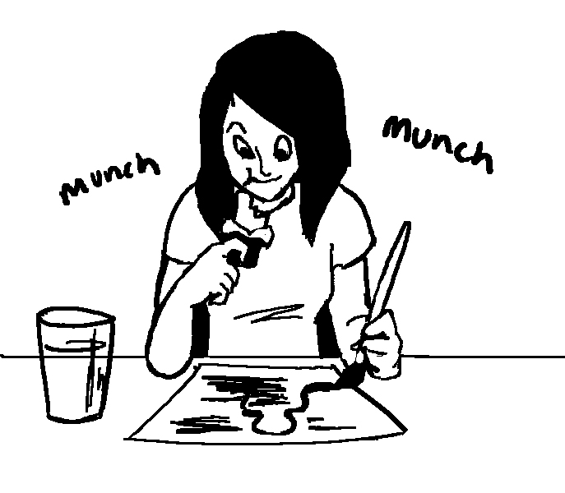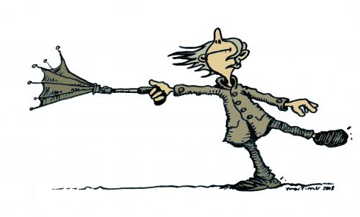

**A.1 Summary Exercise 3 – Linking up two contrastive ideas**

Use the connectives in the brackets to link up the two ideas.

Example: Nevertheless,

The weather was bad. Many fans went to the concert.

The weather was bad. Nevertheless, many fans went to the concert.

**🟊🟊 Use Capital Letters (ABC abc) and Commas ( , ) ! 🟊🟊**

1. It was cold. Susan didn’t put on her coat. (although)

Although it was cold, Susan didn’t put on her coat.

2. The car is new. It keeps breaking down. (however)

The car is new. However, it keeps breaking down.

3. I can sleep. It is noisy. (even though)

I can sleep even though it is noisy.

4. We had no money. We had a good time. (nevertheless)

We had no money. Nevertheless, we had a good time.

5. I was feeling ill. I went to work the next day. (although)

Although I was feeling ill, I went to work the next day.

6. The salary was very low. She took the job. (although)

Although the salary was very low, she took the job.

7. Tim and David live next door. They do not see each other. (but)

Tim and David live next door but they do not see each other.

8. Peter feels hot. He has already turned on the fan. (even though)

Peter feels hot even though he has already turned on the fan.

**A.2 Showing results ( so / Therefore, / As a result, )**

**A.2.1 Notes**

|  |
| --- |
| **Kelly was sick so she stayed in bed.**  **OR**  **Kelly was sick. Therefore, she stayed in bed.**  **OR**  **Kelly was sick. As a result, she stayed in bed.** |

* We use ‘**so**’, ‘**Therefore,**’ and ‘**As a result,**’ to show the **result** of the first action.
* We put ‘**so**’ in the **middle** of a sentence **before the result or purpose**.
* We use ‘**Therefore**’ or ‘**As a result,**’ to **start** the second sentence for **result**.

Usage: **Action 1**: Kelly was sick.

**Action 2**: Kelly stayed in bed. (**Result**)

🡺 Kelly was sick **so** she stayed in bed. (Kelly)

**A.2.1 Exercises – Using the correct connectives**

Fill in the blanks with ‘**so**’, ‘**Therefore**,’ and ‘**As a result,**’. For questions 1 – 3, circle the correct answers.



1. Ben wanted to see the sunrise (therefore, / so) he got up very early.

Ben wanted to see the sunrise. So he got up very early.

1. The concert was cancelled. (As a result, / so) we went home early.
2. Summer is very hot (so / as a result,) we want to go swimming.
3. The taxi is expensive. Therefore / As a result, I take the bus.
4. The door was locked. Therefore / As a result, we needed to wait outside.

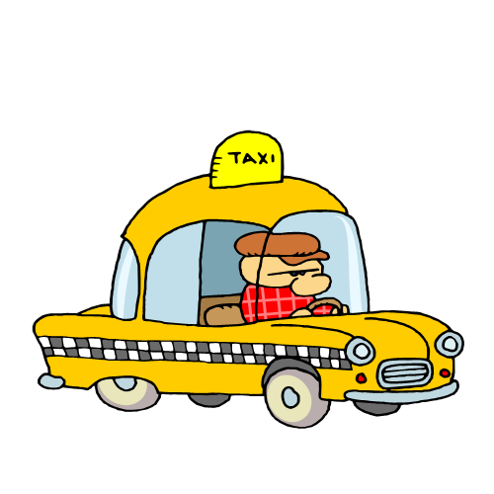

**A.3 Adding information**

**(Also, / Besides, / In addition, / Furthermore, / Moreover, What is more,)**

**A.3.1 Notes**

|  |
| --- |
| **Also / also / Besides, / In addition, / Furthermore, /**  **Moreover, / What’s more** |

|  |
| --- |
| **Hiking is a good exercise. Swimming is also a good exercise.**  **OR**  **Hiking is a good exercise.**  **Also, / Besides, / In addition, /Furthermore, / Moreover, / What’s more,**  **swimming is a good exercise.** |

* We use “**Also, / also / Besides, / In addition, / Furthermore, / Moreover, / What’s more,”** to **add information (e.g. reasons, examples, ideas)** to what has already been said.
* We put “**Also, / Besides, / In addition, / Furthermore, / Moreover, / What’s more,”** at the beginning of the second sentence.
* Usage: **Information 1**: **Hiking** is a **good** exercise.

**Information 2**: **Swimming** is a **healthy** exercise. **(Add information)**

🡺 **Hiking** is a **good** exercise**.** **Also, / Besides, / In addition, /Furthermore, / Moreover, / What’s more,** **swimming** is a **healthy** exercise.

* We can put ‘**also**’ in the **middle of the second sentence**.
* It usually comes **after the subject**, **after the verb** **‘to be’,** **after a modal verb or at the end**.
* Example 1 – After the *subject*:

Hiking is a good exercise. ***Swimming*** **also** is a healthy exercise.

* Example 2 – After the verb ‘to be’:

Hiking is a good exercise. Swimming ***is* also** a healthy exercise.

* Example 3 – After the modal verb:

Hiking is a good exercise. Swimming ***can* also** be a healthy exercise.

* Example 4: – At the end:

Hiking is a good exercise. Swimming isa healthy exercise **also**.

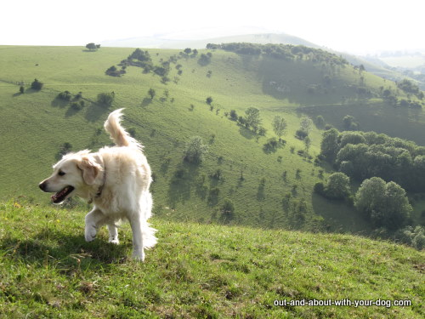

**A.3.1 Exercises – Adding information**

Add information with the help of the connectives in brackets.

E.g.: The company offers cheap Internet service. The company makes software free. (In addition,)

Ans: The company offers cheap Internet service**.** **In addition,** **it** makes software free.

1. Amy is very rich. Amy is beautiful. (also)

Amy is very rich. Also, she is beautiful.

2. That flat isn't big enough for us. It's too expensive. (moreover,)

That flat isn’t big enough for us. Moreover, it’s too expensive.

3. Allen enjoys noisy PE lessons. Allen loves quiet English lessons. (besides,)

Allen enjoys noisy PE lessons. Besides, he loves quiet English lessons.

4. John is handsome. John is rich. (moreover)

John is handsome. Moreover, he is rich.

5. This little girl sings sweetly. She can play the piano very well. (also)

This little girl sings sweetly. She can also play the piano very well.

6. We live in the same building. We study at the same school. (also,)

We live in the same building. We also study at the same school.

7. I enjoy reading newspapers. I love story books. (moreover)

I enjoy reading newspapers. Moreover, I love story books.

8. There is a moon tonight. There are a lot of stars. (besides,)

There is a moon. Besides, there are a lot of stars.

9. Eva is good at English. She is a very polite student. (besides,)

Eva is good at English. Besides, she is a very polite student.

**A.4 Happening at the same time (Meanwhile, / In the meantime,)**

**A.4.1 Notes**

|  |
| --- |
| **Peter is taking a shower. Meanwhile, he is singing freely.**  **OR**  **Peter is taking a shower. In the meantime, he is singing freely.** |

* We can use ‘**Meanwhile,**’ or ‘**In the meantime,**’ to say that **two actions** are happening **at the same time**.
* We usually put them **at the beginning of the second sentence**.
* Usage: Action 1: Peter **is taking a shower** now.

Action 2: Peter **sings** freely.

🡺 Peter is taking a shower**.** **Meanwhile,** / **In the meantime,** he sings freely.

(Peter 🡺 he)

**=** Peter is taking a shower **while** he is singing freely.

(Peter 🡺 he)

**= While** Peter is taking a shower**,** he is singing freely.

(Peter 🡺 he)

* We can use ‘**while**’ or ‘**While…,**’ to say: **during** the time that something is happening.
* Usage: **Long** Action **1**: We **were having** dinner.

**Short** Action **2**: They **arrived**.

🡺 They **arrived** **while** we **were having** dinner. OR

🡺 **While** we **were having** dinner, they **arrived**.

* We can use ‘**when**’ or ‘**When…,**’ to say: **after** or as soon as something happens.
* Usage: Action **1**: I **get** home.

Action **2**: I **will phone** you again.

🡺 I **will phone** you again **when** I **get** home. OR

🡺 **When** I **get** home, I **will phone** you again.

**A.4.1 Exercises – Choosing the correct connectives**

Complete these sentences with ‘**Meanwhile,**’ / ‘**In the meantime,**’ ‘**when**’ and ‘**while**’.

For questions 1-5, circle the correct answers.

1. I fell down carelessly (while / meanwhile) I was dancing.
2. I will buy a new mobile phone for you this weekend. (In the meantime, / when) you can use mine.
3. (When / In the meantime, / While) Fiona was cooking, Uncle Sam phoned her.
4. Miss Chan entered the classroom. (When / Meanwhile / while) some students were eating.
5. My sister can do her homework. (When / while / In the meantime,) she can listen to soft music.
6. My mum will do her housework when she finishes all the cooking.
7. An all-rounded student should play sports well in a school term. In the meantime/ Meanwhile, he can have good results in his studies too.
8. The rope skipping team members can skip. In the meantime/ Meanwhile, they can do many other moves.

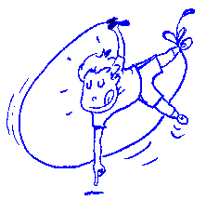

**A.1–4 Summary Exercises – Choosing the correct connectives**

Complete the following sentences with suitable connectives that you have just learned. For questions 1-5, circle the correct answers.

|  |  |  |
| --- | --- | --- |
| Part A: | Contrasting ideas | * **but /** * **However, / Nevertheless, / Nonetheless,** * **although / Even though /** * **Although… , /** * **though** |
| Part B: | Showing results | * **so /** * **Therefore, / As a result,** |
| Part C: | Adding information | * **also /** * **Also, / Besides, / In addition, / Furthermore, / Moreover, / What is more,** |
| Part D: | Happening at the same time | * **Meanwhile, / In the meantime,** * **while** * **when** |

1. We went fishing (also / but ) the weather was awful.

2. The food was cold (while / so) she was angry.

3. (As a result, / Although) I was tired, I managed to finish the work.

4. I hurt myself (when / while / besides,) I was playing tennis.

5. We will turn back (when / so /meanwhile,) it starts raining.

6. Sam is a very diligent student. He is also very obedient.

7. Uncle Wong will visit us tonight. Therefore / As a result, let’s tidy up our rooms.

8. Being a professional artist, you have to be confident in yourself under the spotlight. Also / What is more / Furthermore / Moreover / In addition / Besides, you have to learn from other experienced artists.

9. I enjoy reading this magazine. The content is rich. It also has many beautiful pictures.

10. It was a rainy night so I decided to stay at home and watch TV.

(11. While the singer was singing on the stage, the technician dimmed the light.)

**Additional Exercise**

**Exercise 1**

**School productions: Something for everyone**

My brother Tim and I think school productions are very entertaining. (1)  (*As a result / Moreover / Nevertheless*), we take part in as many of them as we can.

Tim wants to be an actor one day. (2)  (*Furthermore / However / Therefore*), he really likes performing in plays. In fact, he thinks plays are much better than other types of school productions.

(3)  (*Furthermore / However / Therefore*), I disagree with him. I like musicals much more because I am really interested in singing and dancing.   
(4)  (*Furthermore / Nevertheless / Therefore*), I want to learn how to play a musical instrument one day.

Tim and I both agree that participating in these productions makes school much more interesting. (5)  (*However / Moreover / Therefore*), the productions come in different forms and styles to cater for people with different interests. Some people think school productions are just a waste of time. (6)  (*As a result / Moreover / Nevertheless*), we think everybody should try to participate in one at least once.

**Exercise 2**

1. Tina is a very friendly student. Furthermore, she is really helpful.
2. I don’t like watching musicals. Besides, the tickets are usually very expensive.
3. Festival Walk has many shops. In addition, it has many restaurants.
4. Lucas often donates money to charity. Moreover, he does a lot of volunteer work.
5. Danny is the chairperson of the Drama Club. Also, he is the leading actor in this year’s school play.
6. I don’t like watching horror films. Moreover, the film does not have famous stars.
7. The bus stop is far away from my home. Besides, I hate chasing after a bus.
8. Mary is the smartest student in our class. In addition, she is very kind.
9. Kitty likes singing songs. Nevertheless, she doesn’t want to join the singing contest.
10. The thieves broke into the house but they didn’t take anything.
11. We had practised for months, However, we didn’t win the football match.

**END**